**EXPERIMENT-2**

**Note: I Amended the questions according to table created by me.**

**Que. Creating Table for Employee as mentioned.**

**Based on Emp table Columns are EmpNo, Ename, Job, Salary, Commission, DeptNO Insert 5 records by storing Null value in some records for commission column.**

Ans.

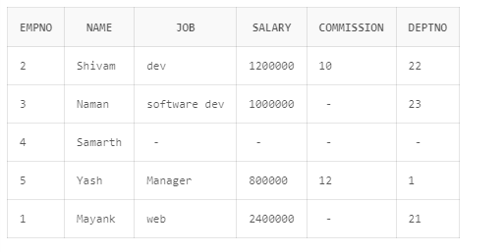

Q1) Get employee no and employee name who works in dept no 23?

Ans.

|  |
| --- |
| SELECT * FROM employee  WHERE DEPTNO='22'; |

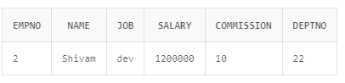

Q2) Display the employee names of those clerks whose salary > 1000000?

Ans.

|  |
| --- |
| SELECT NAME FROM employee  WHERE SALARY>'1000000'; |

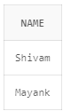

Q3) Display name and job of dev& Software dev?

Ans.

|  |
| --- |
| SELECT NAME,JOB FROM employee  WHERE JOB='dev' OR JOB='software dev'; |

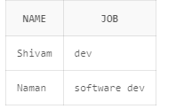

Q4) Display all details of employees whose salary between 1200000 and 800000 ?

Ans.

|  |
| --- |
| SELECT * FROM employee  WHERE SALARY>='800000' AND SALARY<='1200000'; |

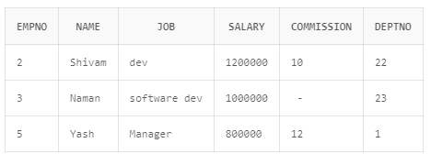

Q5) Display all details of employees whose dept no is 1, 21, or 23 ?

Ans.

|  |
| --- |
| SELECT * FROM employee  WHERE DEPTNO='1' OR DEPTNO='21' OR DEPTNO='23'; |

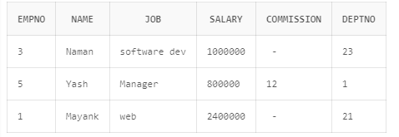

Q6) Display name of those employees whose commission is NULL ?

Ans.

|  |
| --- |
| SELECT * FROM employee  WHERE COMMISSION IS NULL; |

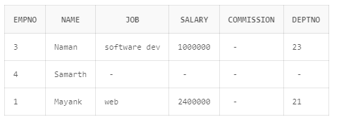

Q7) Display dept no & salary in ascending order of dept no and with in each dept no salary should be in descending order ?

Ans.

|  |
| --- |
| SELECT * FROM employee  ORDER BY SALARY ASC,DEPTNO ASC; |

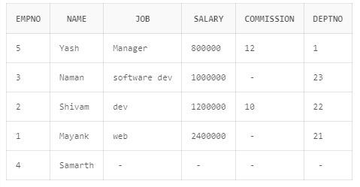

Q8) Display name of employees having two ‘a’ or ‘A’ chars in the name ?

Ans.

|  |
| --- |
| SELECT NAME FROM employee  WHERE (NAME LIKE '%a%a%' OR NAME LIKE '%A%A%'); |

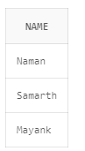

Q9) Display the name of the employees whose second char is ‘b’ or ‘B’ ?

Ans.

|  |
| --- |
| SELECT NAME FROM employee  WHERE (NAME LIKE '_b%' OR NAME LIKE '_B%'); |

OUTPUT: NO DATA FOUND AS I DONT HAVE ANY NAME WHOSE SECOND CHAR IS B.



Q10) Display the name of the employees whose first or last char is ‘a’ or ‘A’ ?

Ans.

|  |
| --- |
| SELECT NAME FROM employee  WHERE (NAME LIKE 'a%' OR NAME LIKE 'A%' OR NAME LIKE '%b' OR NAME LIKE '%B'); |



Q11) Display maximum, minimum, average salary of employees.

Ans.

|  |
| --- |
| SELECT MIN(SALARY),MAX(SALARY),AVG(SALARY) FROM employee ; |

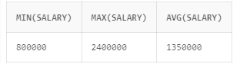

Q12) Display total number of employees working in deptno 20

Ans.

|  |
| --- |
| ADDING SOME ENTRIES IN DEPTNO 20: |

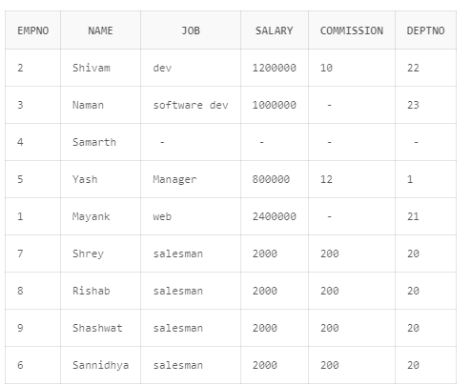

|  |
| --- |
| SELECT COUNT(EMPNO)  FROM EMPLOYEE  WHERE DEPTNO='20'; |

OUTPUT:

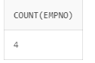

Q13) Display total salary paid to clerks

Ans.

|  |
| --- |
| SELECT SUM(SALARY)  FROM EMPLOYEE; |

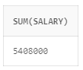

Q14) Display system date

Ans.

|  |
| --- |
| select SYSDATE from dual |

OUTPUT:

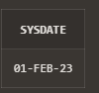

Q15) Display the result of (12*12)/13

Ans.

|  |
| --- |
| select (12*12)/13 from dual |

OUTPUT:

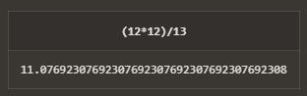

Q16) Display info of ‘raj’ irrespective to the case in which the data is stored.

Ans.

|  |
| --- |
| SELECT *  FROM table_name  WHERE UPPER(column_name) = UPPER('raj'); |